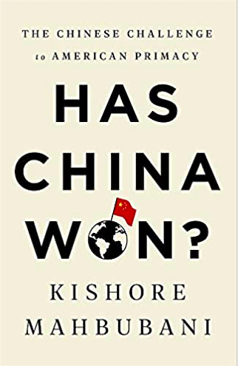

Has China Won?
The Chinese Challenge to American Primacy
Kishore Mahbubani
Kishore Mahbubani, veteran Singaporean diplomat, makes a salient point: lack of a cohesive United States China policy is based on a categorical misperception. The CCP is not the Chinese Communist Party, despite the continued use of the name, but is the Chinese Civilization Party. China has reverted to its historic centralized rule, trying to maintain control over far off and disparate provinces, each with regional cultures of their own, resulting in a robust economy, but limiting foreign policy objectives. This has led to strategy mistakes, very big mistakes, in both Washington and Beijing.
China’s Big Mistake is alienating the American business community in China, contributing to bi-partisan anti-Chinse positions that no pro-China politician or business person would have countenanced previously. The issues are commonly understood: intellectual property theft, bureaucratic stonewalling, constantly changing visa requirements, in my own case forcing me to sell my WFOE as I approached my late 60s, and this is only a very small list of the daily tribulations one faces in China, and that’s if you are compliantly friendly. China’s alienation of the US business is a failure destined for revenge.
The Big Mistake of the United States is the weaponization of the dollar. Mahbubani asks “why should any country’s trade and growth depend on US policies premised on the use of the dollar as a weapon?” Trade wars, illogical tariffs incredibly presented as “billions” paid into the US Treasury by China.
Or, invoking a treaty to arrest a Chinese citizen in a third country for what seems a minor Iran sanctions infraction years ago. In the normal course of sanctions violations, corporations are convicted, not their executives.
What sense, Mahbubani asks, does it make to base a serious diplomatic escalation on Iran, a country of 79 million people that is no threat to the security of the United States? Penalizing countries and companies around the world over Iran is leading several countries to develop alternatives to settling accounts in dollars. Many countries only support the US now because of the ubiquity of the dollar. And that won’t last. Nobody likes a dollar bully, perhaps especially China which has the potential economic power to lead a coalition against the dollar as a global reserve currency.
The author spends a chapter on US problems that he sees as further evidence of decline. There is the standard exposition of crumbling underfunded infrastructure, while the rich compete for the newest Gulfstreams, yachts, and the newest affectation, personal submersibles. He wonders, what is the political outcome when most Americans seem to have awakened in 2020 to the fact that the average income of the bottom 50% has declined over the last 30 years?
The point is relevant to the China – US contest. Mahbubani discusses at some length the George Kennan X article in Foreign Affairs that formed the basis of Cold War containment of the Soviet Union. He emphasizes Kennan’s point that just as with the Soviet Union, a main requirement for success with China will also be the maintenance of the “American spirit” and sense of shared sacrifice. The current open wounds of gross inequality and failure to reconcile racial justice makes that nearly impossible. Americans are increasingly unhappy, but according to Mahbubani Chinese people are not. As a civilization the Chinese people are experiencing their best standard of living in a very long history. Spirit are higher in China.
So which country wins with such a taxonomy of problems? The author writes that over a hundred countries trade more with China than with the United States. He fears that decoupling will drive the US into third place, not just second, due to Washington’s myopic, scattered policies. He believes the current US administration’s assumption of continued American dominance is reminiscent of the 19th Qing mandarins who failed to adjust to the rise of West. Today, only the American business community in China is poised to influence American policy in a positive and realistic direction.
Ultimately, Mahbubani asks an awkward question. If the goal of competition between China and the United States to improve the well-being of citizens of both countries, who wins? Read this worthwhile book and find out. Sometimes getting an opinion outside the arc of Beijing and Washington can be illuminating.

